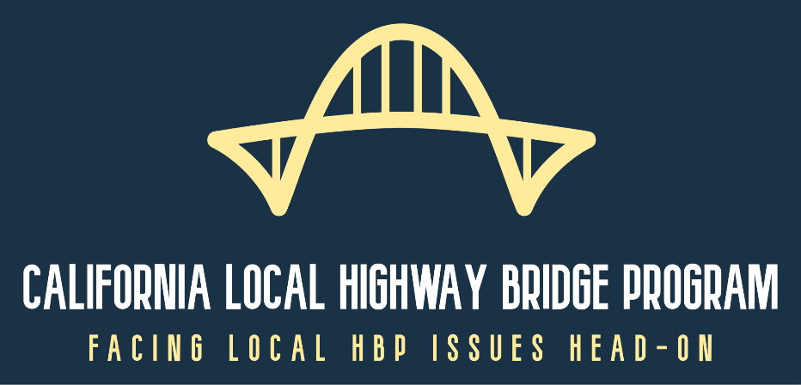
**REMINDER**
Webinar Outreach Event
Local Highway Bridge Program Reform Policies

Reminder: The Local Highway Bridge Program Reform Policy webinar outreach event will be held this Wednesday June 3rd from 1:30-3:30pm (Click to signup) and this Thursday June 4th from 10:30am-noon (Click to signup). Note that the agenda is the same for both sessions and includes background on advisory committee activities, an overview of the reform policies, and a chance for attendees to comment and submit questions for panelists to answer. For more background information visit our Highway Bridge Program blog or send an email to california.local.HBP@gmail.com.

Reform Policy Summary: Following is a summary of the reform policies that will be discussed during the webinar:

Policy #1: All projects must have a Field Review, Type Selection, Hydraulic Report, 65% and 95% Plans reviewed by Caltrans Headquarters and/or Structures Local Assistance
Policy #2: All bridges are only funded at the cost of the basic structural solution. No aesthetic treatments will be eligible for Highway Bridge Program (HBP) reimbursement (except Historic Bridge Projects). The HBP will not pay for signature structures.
Policy #3: The HBP will not fund approach roadwork beyond what is necessary to build abutments. Approach roadway costs capped will be at a set percentage unless otherwise approved by HBP managers (the percentage will be determined at a later date).
Policy #4: Local Agency project sponsors will be required to submit regular project status reports replacing the annual survey.
Policy #5: All changes to programmed project costs must be submitted to and approved by HBP Managers using LAPG 6-D. HBP programming will no longer be changed using the annual survey.
Policy #6: Caltrans HBP managers will include cost escalation factors with project programming in addition to what Local Agencies request.
Policy #7: Cap HBP funding on High Cost Bridge Projects at $80 million.
Policy #8: All bridge project scopes will start as rehabilitation or preventative maintenance. Proposed replacements must be justified by engineering analysis and approved by the HBP managers.
Policy #9: Only minimum AASHTO roadway standards are eligible for HBP reimbursement

