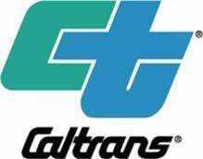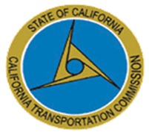
California Transportation Stakeholders:
Thank you for attending the 2022 Transportation Asset Management Plan (TAMP) Financial Planning Workshop held on May 24, 2021. Please visit the 2022 TAMP website for the presentation materials and to provide additional feedback through a survey monkey available at: https://dot.ca.gov/programs/asset-management/virtual-workshop-series-for-the-2022-tamp-update

Please join us for the next session on the development of the 2022 TAMP by attending our TAMP Risk Management Workshop to be held in two sessions on:

Date: Wednesday, June 23, 2021 from 1:00-3:00 PM
Thursday, June 24, 2021 from 9:00-11:00 AM

*After each of the TAMP Virtual Workshops end, Caltrans will host an optional informal Q&A session. You will not need to log out of the Workshop to attend.

This will be a two-part workshop that includes review of risks identified in the 2018 TAMP and updates needed for the 2022 TAMP including prioritization of risks and potential for mitigation strategies and actions. We will also discuss the federal rule related to evaluation of locations with repeat damage. Finally, the workshop will conclude with how best to bring risk into the TAMP by considering it as part of performance analysis and investment strategies.

The TAMP Workshop Agenda and additional materials will be sent to you prior to the workshop. For more information, please visit Caltrans TAMP development webpage: https://dot.ca.gov/programs/asset-management/california-transportation-asset-management-plan,

Please respond to the outlook invitation on your attendance. If you have any questions, please contact us via e-mail to CT-TAM@dot.ca.gov.

